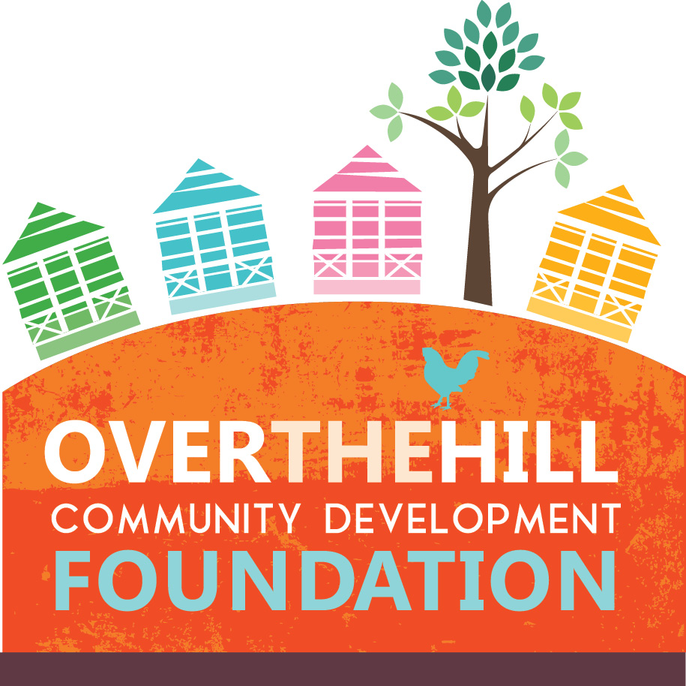

Grant Proposal Application

The Over-the-Hill Community Development Foundation is a non-profit organization whose mission is to advance positive social, environmental and economic progress in the Over-the-Hill Community.

The Over-the-Hill Community Development Foundation (“the Foundation”) is a non-profit company registered in The Commonwealth of The Bahamas. It aims to bring lasting and tangible benefits to the inner-city area of New Providence colloquially known as “Over-the-Hill.” Philanthropic donations and contributions are accepted and deployed under the stewardship of the Foundation’s independent Board of Directors.

The Foundation awards grants towards projects, initiatives and programs that meaningfully contribute toward the development of Over-the-Hill. Citizens, residents and organizations based in The Bahamas are eligible to apply for grant funding. Grant applications are accepted on a triannual basis during the following cycles:
- March 1 through March 15
- July 1 through July 15
- November 1 through November 15

To apply, please submit a grant proposal with summary information and a narrative as outlined on pages 4 and 5 of this grant application. Please email completed applications to info@overthehillfoundation.org. Each successful grant awardee will receive funding in tranches and will be required to satisfactorily submit a grant report within sixty (60) days of receiving initial funding in order to obtain the remainder of the grant.

Grant Proposal Application Criteria

Each grant application must meet the following criteria to be eligible for consideration:

- Each grant applicant (if an individual) must be a citizen or resident based in The Bahamas. Each grant applicant (if an organization) must be registered in The Bahamas and ordinarily conduct the majority of its activities in The Bahamas.
- Each grant application must address one or more of the six pillars of community development outlined by on the website of the Over-The-Hill Community Development Foundation :
  - Social Empowerment
  - Economic Empowerment
  - Rejuvenation
  - Smart Technology
  - Green Technology
  - Youth and Elderly Empowerment
- Note: For the November 2022 application period, special consideration will be given to proposals targeting the Green Technology pillar of community development.

- Each grant application may propose a budget of up to $10,000.00.
- The minimum grant application budget is $3,000.00.
- Favorable consideration will be given to proposals that demonstrate alignment between funding needs and projects/initiatives needed.
- Each individual or organization is prohibited from submitting more than one grant proposal application in a given cycle.

Grant Proposal - Summary Information

Name: Click or tap here to enter text.
Email address: Click or tap here to enter text.
Telephone number: Click or tap here to enter text.
Organization (if applicable): Click or tap here to enter text.
Amount of Grant Requested: Click or tap here to enter text.

Pillars of community development targeted by this grant proposal (select all that apply):
Social Empowerment ☐
Economic Empowerment ☐
Rejuvenation ☐
Green Technology ☐
Smart Technology ☐
Youth and Elderly Empowerment ☐

Project Description (describe how the funds would be used to meet the purpose of the Over-the-Hill Community Development Foundation, limit to 150 words):

Grant Proposal - Narrative
Please follow the outline below, limiting your narrative to 2,500 words or less. Please include your name or your organization's name and page number in the footer; and the date submitted in the header.

Background, Rationale and Coherence with the Foundation’s Purpose
- Clearly articulate the problem you are addressing, including the scope, history, and causes of the problem. (Please include data if possible.)
- Demonstrate how this problem is consistent with the Foundation’s purpose.
- Please describe your vision of success for solving the problem stated above.
- What are the necessary steps to achieve your vision of success?

II. Project Objectives
  - Describe the overall objective(s) of the project.
- Please specify the measurable outputs and outcomes to be accomplished by the project, showing how these relate to specific project objectives and activities.

III. Project Design and Implementation Plan
- Please describe the project design and major activities required to achieve the stated objectives.
- Include a clear project timeline, indicating who is responsible for what activity and when it will be implemented
- Please identify key milestones that will be used to measure progress on the implementation of project activities along the timeline. If the grant is awarded, release of subsequent grant payments by the foundation will be based on achieving the specified milestones.
- Demonstrate how the mechanics of the project reinvests in and involves members of the Over-The-Hill community.

IV. Potential Risks
- Please articulate the risks that could inhibit the success of the project.
- Describe the strategies you or your organization will employ to mitigate these risks.

V. Monitoring and Evaluation
- Please describe the proposed methodology for measuring project success according to the indicators previously specified.

VI. Organizational Capacity and Management Plan
- Please provide a brief description of the organization's history, mission, and structure or if an individual, please describe your capacity to undertake this project.

VII Budget
- Please provide a total itemized budget for your project, including the proposed uses of the grant.
- Please include invoices and estimates from vendors where appropriate.

https://www.overthehillfoundation.org/what-we-do

